DATABASE SYSTEMS PROJECT REPORT

**SYSTEM ANALYSIS:**

# BACKGROUND RESEARCH:

This project aims to develop an inventory system for tracking workstations, laptop computers, and the software installed on these computers used by employees in a large multinational consulting company. The system analysis included understanding the company’s requirements, the existing practices regarding inventory management and industry standards for database designing.

# KEY ISSUES:

The main challenges or issues that were kept in mind to ensure the effectiveness of the database system are listed below.

1. **DATA ACCURACY:** The data entered and stored in the database must be accurate and updated regularly to have up-to-date information. This is extremely crucial for the successful operation of a database system as inaccurate data can lead to disturbances in decision-making and operations of the company.
2. **SCALABILITY:** The database system must be able to accommodate the growing inventory and staff of the company. This is extremely important in the long run as the company’s growth would involve increase in workforce and inventory. Even with the increase in this, the database must be able to handle large amounts of data without any significant performance degradation.
3. **EASY TO NAVIGATE:** The interface must be easy to navigate for easy data entry and retrieval by employees of the company. This will reduce errors and streamline the work process.
4. **EFFICIENT AND ACCURATE QUERIES:** Efficient queries regarding retrieval of certain inventory and employee data is crucial to make sure that users can get the data that they want easily. This enhances the overall user experience.

# BUSINESS RULES:

The business rules that were followed while making the ER Diagram and the database are as follows:

1. Each workstation or laptop must have a unique inventory tag number.
2. Workstation or Laptop can be assigned to multiple employees over time.
3. Software packages can be installed in multiple laptops.
4. Employees must be associated with at least one workstation or laptop.
5. Only personnel with authorization must be able to access, enter and modify data.

**DESCRIPTION OF DATABASE IMPLEMENTATION:**

# DATABASE MODEL:

The database model consists of five tables namely:

EMPLOYEE, ASSIGNED_EMPLOYEE INVENTORY, INVENTORY LAPTOP, SOFTWARE, SOFTWARE_TRACLER.

These tables are designed based on the identified entities in the case and their relationships. The figure below is the ER diagram which helps us identify the relationships and the tables.

# ER DIAGRAM:

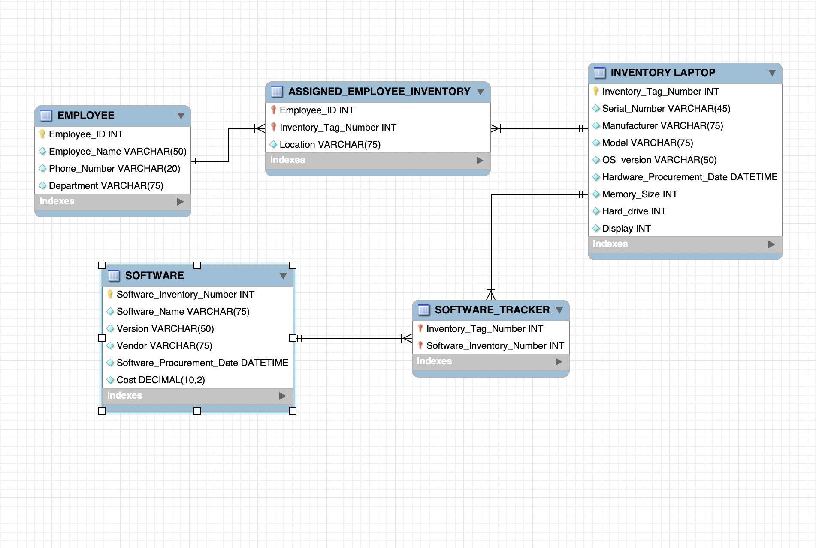

**DESIGN AND DEVELOPMENT:**

1. An ER diagram was created by first identifying all the entities and keeping in mind the

business rules of the case. The foreign keys, and primary keys were identified in all the tables and the relation was studied between the tables using the ER diagram.

1. The database tables were then created using SQL commands, with appropriate data types. 3.Relationships were established between the tables using the foreign keys.

4.Sample queries were developed for the scenarios mentioned in the case study to retrieve inventory and employee data.

# NORMALIZATION OF TABLES:

The process of normalizing the tables is done to eliminate redundancy of data and also improve the integrity of the data. It is observed that the following are the relationships between the tables in the database:

1. EMPLOYEE and ASSIGNED_EMPLOYEE_INVENTORY tables exhibit a one to many relationship. This represents the scenario where one employee can be assigned to several laptops. Each laptop is assigned to only one employee at a time.
2. INVENTORY LAPTOP and ASSIGNED_EMPLOYEE_INVENTORY tables exhibit a one to many relationship. This means that each laptop in the inventory can be assigned to multiple

employees over time, meaning changes in user/usage.

1. INVENTORY LAPTOP and SOFTWARE TRACKER tables exhibit a one to many relationship. This is the scenario where each laptop can have multiple software packages installed. Each software package is tracked separately for each laptop.
2. SOFTWARE and SOFTWARE_TRACKER tables exhibit a one to many relationship.

This means each software package can be tracked multiple times in the software tracker which would reflect installations in different laptops. It means one software package can be installed on multiple laptops.

# DEVELOPMENT OF SAMPLE QUERIES:

## Displaying inventory tag number and hardware details of a computer assigned to a particular employee.

The code below when run gives us the result that John Doe was assigned to inventory tag

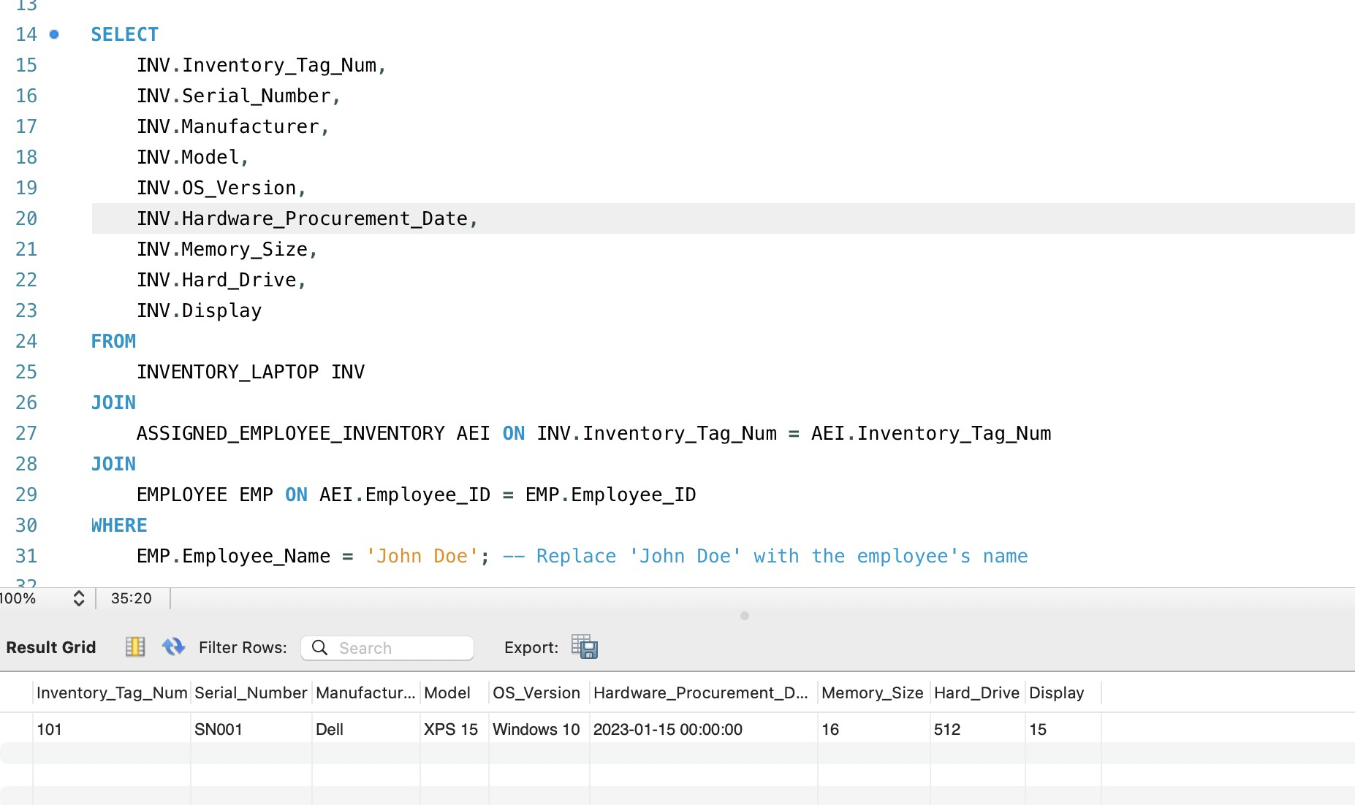number 101, serial number SNOO1, manufacturer model XPS 15, OS_version Windows 10, Hardware_Procurement ID 2023-01-15, memory size 16, hard drive 512 and display 15

## Listing all software packages installed on a specific computer.

The result below shows us that the computer with inventory tag number 101 had three software packages installed in it namely Microsoft Office 365, Norton Security, Tableau Desktop with

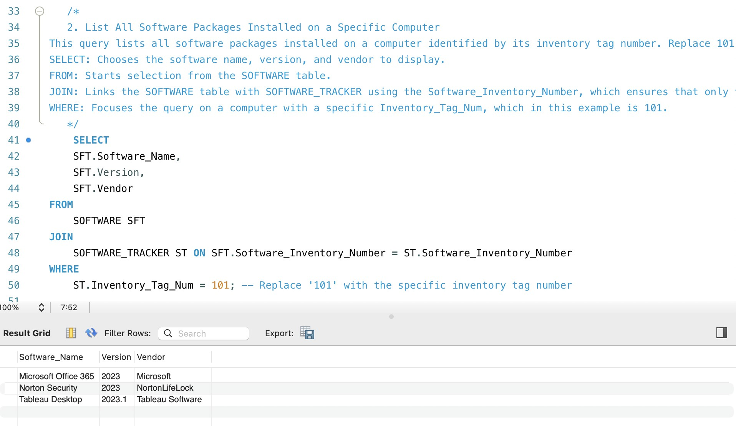versions 2023, 2023, 2023.1 and vendors Microsoft, NortonLifeLock and Tableau Software respectively.

## Finding out which computer model is the most popular

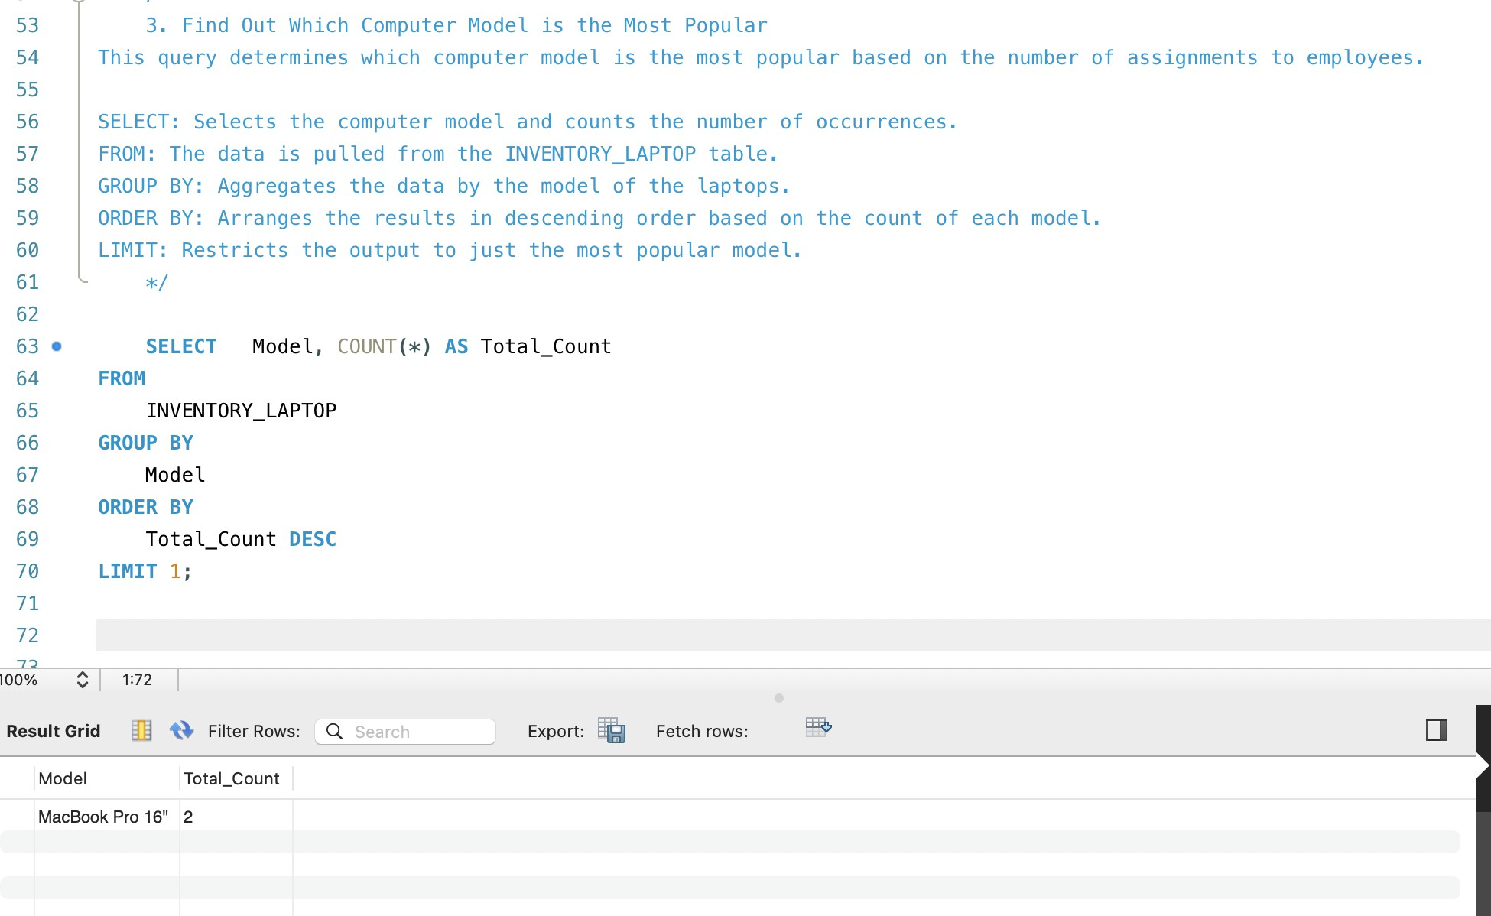It is observed from the result that the most popular computer model is Macbook pro 16” with a total_count of 2.

## Listing top 3 software packages installed in the company.

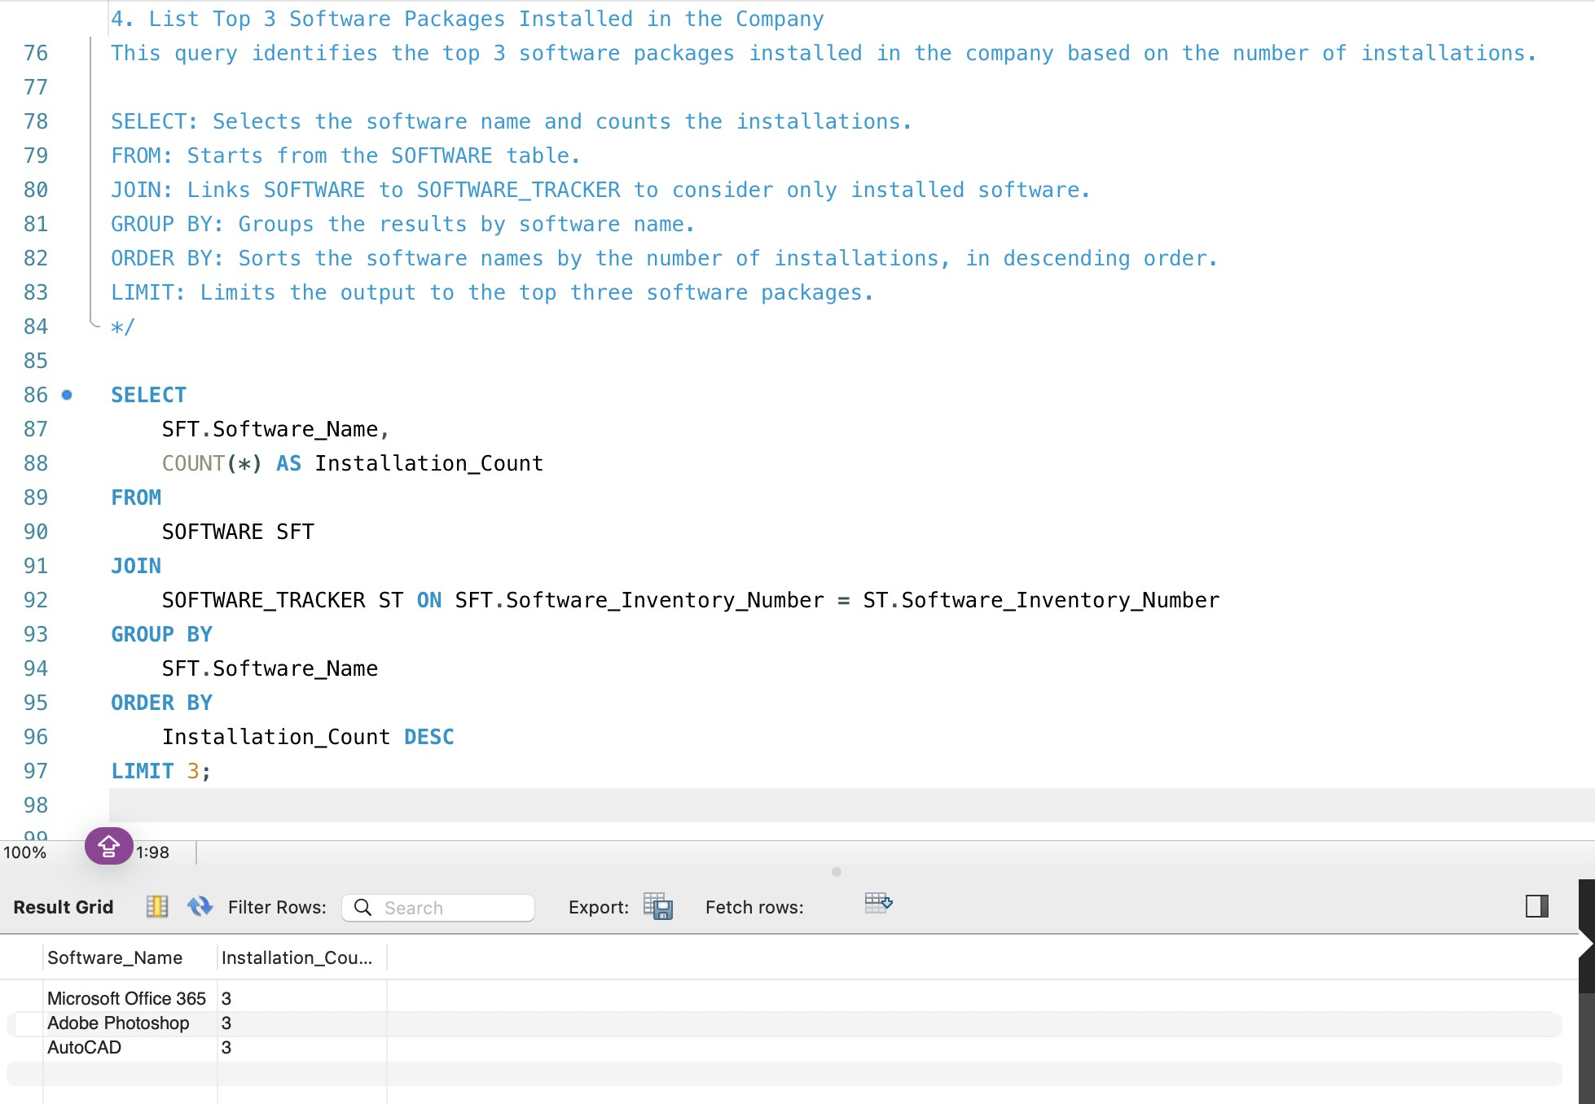The result helps us identify that the top three software packages installed in the company are Microsoft Office 365, Adobe Photoshop, and AutoCAD with an installation count of 3,3 and 3 respectively.

# DATA SOURCES:

The data regarding the employee records, workstation/laptop inventory and software inventory were collected online.

# FINDINGS:

Our findings involved getting an understanding about the most popular software packages, and computers. We could also find out the number of software packages installed in a particular

computer and also the details about the said software. Also, we found out about what computer was assigned to which employee. This gives us a complete clear understanding of the workflow in the company.

## Details of a software installation assigned to an employee:

John Doe was assigned inventory tag number 101, serial number SNOO1, manufacturer model XPS 15, OS_version Windows 10, Hardware_Procurement ID 2023-01-15, memory size 16,

hard drive 512, and display 15.

## Details about which software packages were installed in a particular computer:

The computer with inventory tag number 101 had three software packages installed in it namely Microsoft Office 365, Norton Security, Tableau Desktop with versions 2023, 2023, 2023.1 and vendors Microsoft, NortonLifeLock and Tableau Software respectively.

## Details about the most popular computer:

The most popular computer model is Macbook pro 16” with a total_count of 2.

## Details about the top three software packages in the company:

The top three software packages installed in the company are Microsoft Office 365, Adobe Photoshop, and AutoCAD with an installation count of 3,3 and 3 respectively.

# REVIEW ON DATABASE INTEGRITY AND SECURITY POLICY: DATA INTEGRITY:

To ensure data integrity the following rules were implemented:

1. Normalization techniques were used in the making of the database to ensure minimal data redundancy and ensure data consistency.
2. Only entering valid and accurate data can ensure data validation helps in better accuracy and understanding of data.
3. Utilization of foreign key constraints ensured that the data was consistent across the database.

# SECURITY POLICY:

1. Access to employee records, inventory details, and software licenses should be granted only to authorized personnel in the company.
2. User authentication techniques like passwords, biometrics etc can be enforced to identify the users accessing the database.
3. Network security measures like firewalls can be implemented to protect the database from external threats.

.